# LINE FOLLOWER ROBOT

##### - LOKESH J

##### 25-02-2022

Contents

LINE FOLLOWER ROBOT 1

INTRODUCTION 2

SWOT ANALYSIS 2

REQUIREMENTS 2

High Level Requirements: 2

Low Level Requirements: 3

BLOCK DIAGRAM 3

COMPONENT DIAGRAMS 3

IR SENSOR: 3

Atmega 328 Microcontroller: 4

Motor Driver: 4

DC Motor: 4

ARCHITECTURE 4

BEHAVIOUR DIAGRAMS: 4

• High level behaviour diagram: 4

• Low level behaviour diagram: 5

STRUCTURAL DIAGRAMS: 6

• High level UML diagram: 6

• Low level UML diagram: 6

# 

# 

# INTRODUCTION

A line follower robot is a robot which follows a certain path controlled by a feed back mechanism.

# SWOT ANALYSIS

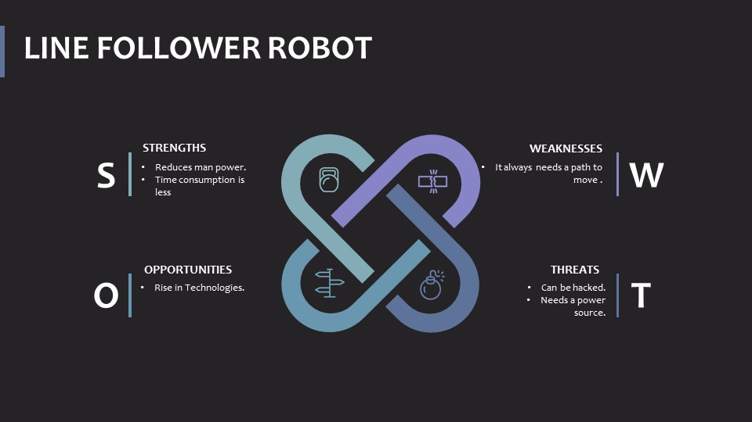

# REQUIREMENTS

* + High Level Requirements.
  + Low Level Requirements.

### High Level Requirements:

|  |  |
| --- | --- |
| **High Level Requirements** | **Description** |
| HLR1 | There shall be Sensor to sense path. |
| HLR2 | Microcontroller shall control our Embedded system. |
| HLR3 | There shall be a Motor driver to control Motor. |
| HLR4 | There shall be a actuator. |

## Low Level Requirements:

|  |  |
| --- | --- |
| **Low Level Requirements** | **Description** |
| LLR1 | Ir sensor shall sense the path and directs the robot to move in the correct path. |
| LLR2 | Atmega 328 shall receive signal from IR sensor and controls motor driver . |
| LLR3 | Motor driver shall control the motors to move either left,right or forward. |
| LLR4 | Dc motor shall act as a actuator. |

# BLOCK DIAGRAM

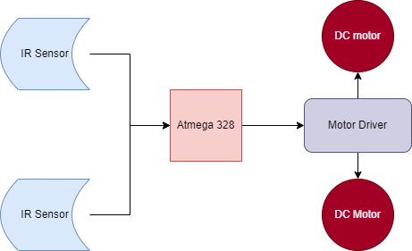

The above block diagram is of Line Follower Robot.

# COMPONENT DIAGRAMS

## IR SENSOR:

* Electronic Device.
* Emits light to Sense objects.
* Senses Radiation which are invisible to eyes.
* Emitter is IR Led.
* Detector is IR Photo diode.

## Atmega 328 Microcontroller:

* **ATmega328**is an 8-bit, 28-Pin AVR Microcontroller.
* Follows RISC Architecture.
* Flash-type program memory of 32KB.
* 2-16 bit timers**.**

## Motor Driver:

* Capable of running two motors .
* Direction of two motors can be controlled independently.

## DC Motor:

* These are small motors .
* Needs low current.
* Acts as a actuator.

ARCHITECTURE

### BEHAVIOUR DIAGRAMS:

### High level behaviour diagram:

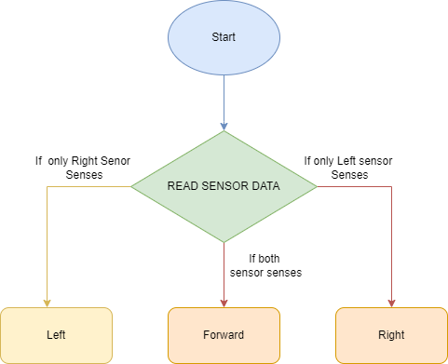

### Low level behaviour diagram:

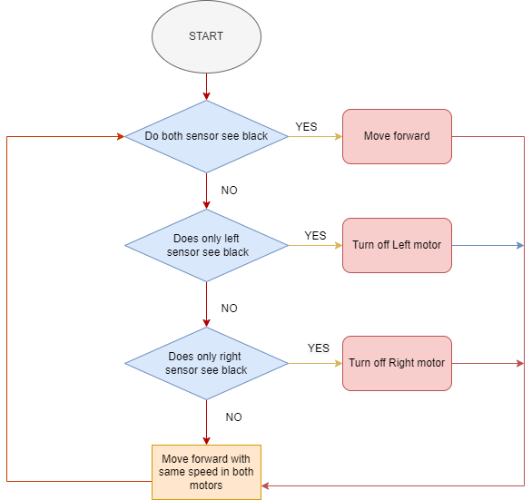

### STRUCTURAL DIAGRAMS:

### High level UML diagram:

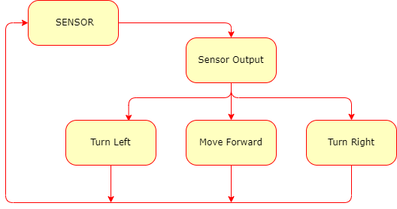

### Low level UML diagram:

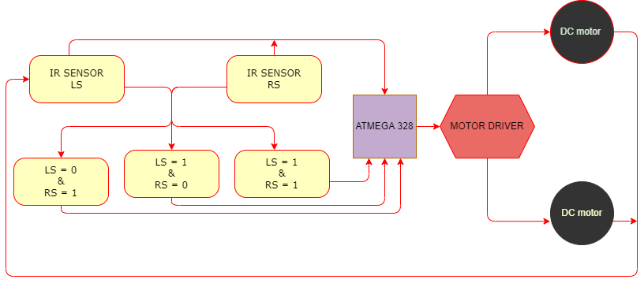

# 

# APPLICATIONS

* **Industrial Applications**: These robots can be used as automated equipment carriers in industries replacing traditional conveyer belts.
* **Automobile applications**: These robots can also be used as  automatic running on roads with embedded magnets.
* **Domestic applications**: These can also be used at homes for domestic purposes like floor cleaning etc.
* **Guidance applications**: These can be used in public places like shopping malls, museums etc to provide path guidance.